**Fall 2025 Sanitary Survey Courses: MARO**

**MARO: Ground Water Sanitary Survey Course Fall 2025 (In-Person)\***

* **Date:** September 29th & September 30th
* **Time:** 8:00AM – 4:00PM
* **Location:** Westchester County Fire Training Center - 4 Dana Road, Valhalla, NY 10595
* **Post Registration Information:** On day 2 of the course, there will be an off-site visit to a public ground water system. Be prepared to carpool to limit the number of cars parked at the facility. Please wear appropriate clothing and shoes. Completion of this course is awarded 12 CEUs for professional engineers. Thank you, and I hope you enjoy this course!
* **Additional Information:** PARKING FOR TRAINING CENTER: All students are requested to park in the parking lot at the top of the hill next to 35 Walker Road (outlined in red on the map). There are stairs are connecting the parking lot with the training facility (circled in green on the map).

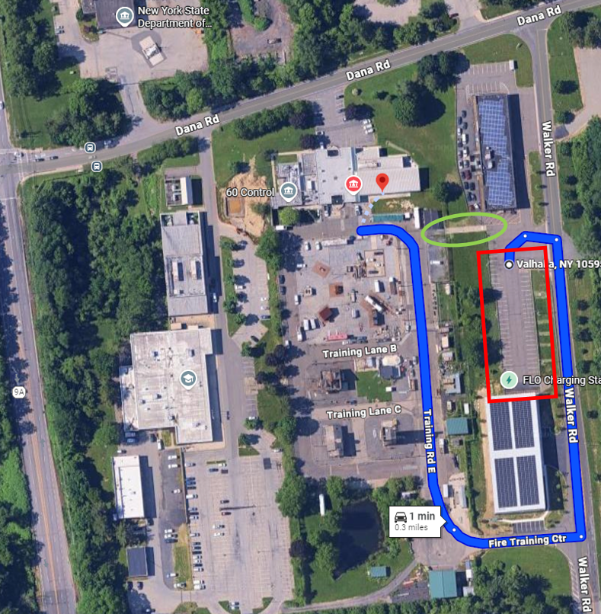

**\*REMINDER:** Dress appropriately for fieldwork on day 2 of the course!!

**MARO: Surface Water Sanitary Survey Course Fall 2025 (In-Person)\***

* **Date:** October 1st & October 2nd
* **Time:** 8:00AM – 4:00PM
* **Location:** Dutchess County Fire Training Center, Department of Emergency Response - 392 Creek Road (Room 113), Poughkeepsie, NY  12601
* **Post Registration Information:** On day 2 of the course, there will be an off-site visit to a public surface water system. Be prepared to carpool to limit the number of cars parked at the facility. Please wear appropriate clothing and shoes. Completion of this course is awarded 10 CEUs for professional engineers. Thank you and I hope you enjoy this course!
* **Additional Information:**

**\*REMINDER:** Dress appropriately for fieldwork on day 2 of the course!!